Name : Kaustav

Reg no : 180905188

Q1

#include <stdio.h>

#include <stdlib.h>

#include <string.h>

int curr = 0;

char str[100];

// --------------------------------------------------

void S();

void T();

void Tprime();

// --------------------------------------------------

void invalid()

{

printf("-----------------ERROR!----------------\n");

exit(0);

}

void valid()

{

printf("----------------SUCCESS!---------------\n");

exit(0);

}

// --------------------------------------------------

void S()

{

if(str[curr] == 'a' || str[curr] == '>')

{

curr++;

return;

}

else if (str[curr] == '(')

{

curr++;

T();

if(str[curr] == ')')

{

curr++;

return;

}

else

invalid();

}

else

invalid();

}

void T()

{

S();

Tprime();

}

void Tprime()

{

if(str[curr] == ',' )

{

curr++;

S();

Tprime();

}

else

invalid();

}

int main(int argc, char const \*argv[])

{

printf("Enter the string \n");

scanf(" %s",str);

S();

if(str[curr] == '$')

valid();

else

{

printf("%c\n" , str[curr]);

invalid();

}

return 0;

}

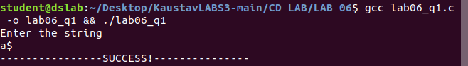

Q2

#include <stdio.h>

#include <stdlib.h>

#include <string.h>

int curr = 0;

char str[100];

// --------------------------------------------------

void S();

void U();

void V();

void W();

// --------------------------------------------------

void invalid()

{

printf("-----------------ERROR!----------------\n");

exit(0);

}

void valid()

{

printf("----------------SUCCESS!---------------\n");

exit(0);

}

// --------------------------------------------------

void S()

{

U();

V();

W();

}

void U()

{

if(str[curr] == '(')

{

curr++;

S();

if(str[curr] == ')')

{

curr++;

return;

}

else

invalid();

}

else if(str[curr] == 'a')

{

curr++;

S();

if(str[curr] == 'b')

{

curr++;

return;

}

else

invalid();

}

else if (str[curr] == 'd')

{

curr++;

return;

}

else

invalid();

}

void V()

{

if(str[curr] == 'a')

{

curr++;

V();

}

}

void W()

{

if(str[curr] == 'c')

{

curr++;

W();

}

}

int main(int argc, char const \*argv[])

{

printf("Enter the string \n");

scanf(" %s",str);

S();

if(str[curr] == '$')

valid();

else

{

printf("%c\n" , str[curr]);

invalid();

}

return 0;

}

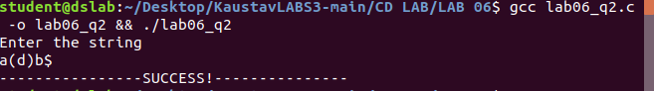

Q3

#include <stdio.h>

#include <stdlib.h>

#include <string.h>

int curr = 0;

char str[100];

// --------------------------------------------------

void S();

void A();

void Aprime();

void B();

// --------------------------------------------------

void invalid()

{

printf("-----------------ERROR!----------------\n");

exit(0);

}

void valid()

{

printf("----------------SUCCESS!---------------\n");

exit(0);

}

// --------------------------------------------------

void S()

{

if(str[curr] == 'a')

{

curr++;

A();

if(str[curr] == 'c')

{

curr++;

B();

if(str[curr] == 'e')

{

curr++;

return;

}

else

invalid();

}

else

invalid();

}

else

invalid();

}

void A()

{

if(str[curr] == 'b')

{

curr++;

Aprime();

}

else

invalid();

}

void Aprime()

{

if(str[curr] == 'b')

{

curr++;

Aprime();

}

// else

// invalid();

}

void B()

{

if(str[curr] == 'd')

{

curr++;

return;

}

else

invalid();

}

int main(int argc, char const \*argv[])

{

printf("Enter the string \n");

scanf(" %s",str);

S();

if(str[curr] == '$')

valid();

else

{

printf("%c\n" , str[curr]);

invalid();

}

return 0;

}

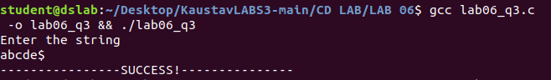

Q4

#include <stdio.h>

#include <stdlib.h>

#include <string.h>

int curr = 0;

char str[100];

// --------------------------------------------------

void S();

void L();

void Lprime();

// --------------------------------------------------

void invalid()

{

printf("-----------------ERROR!----------------\n");

exit(0);

}

void valid()

{

printf("----------------SUCCESS!---------------\n");

exit(0);

}

// --------------------------------------------------

void S()

{

if(str[curr] == '(')

{

curr++;

L();

if(str[curr] == ')')

{

curr++;

return;

}

else

invalid();

}

else if(str[curr] == 'a')

{

curr++;

return;

}

else

invalid();

}

void L()

{

S();

Lprime();

}

void Lprime()

{

if(str[curr] == ',')

{

curr++;

S();

Lprime();

}

}

int main(int argc, char const \*argv[])

{

printf("Enter the string \n");

scanf(" %s",str);

S();

if(str[curr] == '$')

valid();

else

{

printf("%c\n" , str[curr]);

invalid();

}

return 0;

}

